**Docker Assignment**

Create a container with the name container1

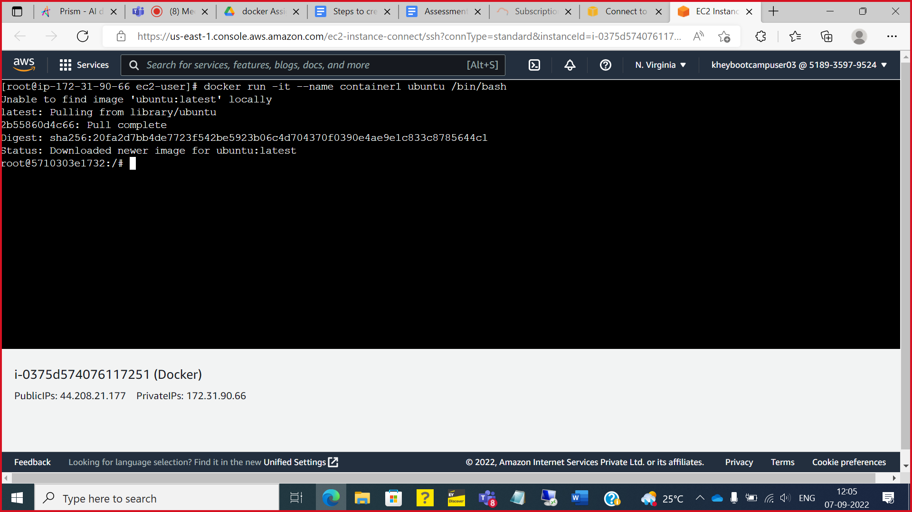

You will enter inside the container1 and there  files

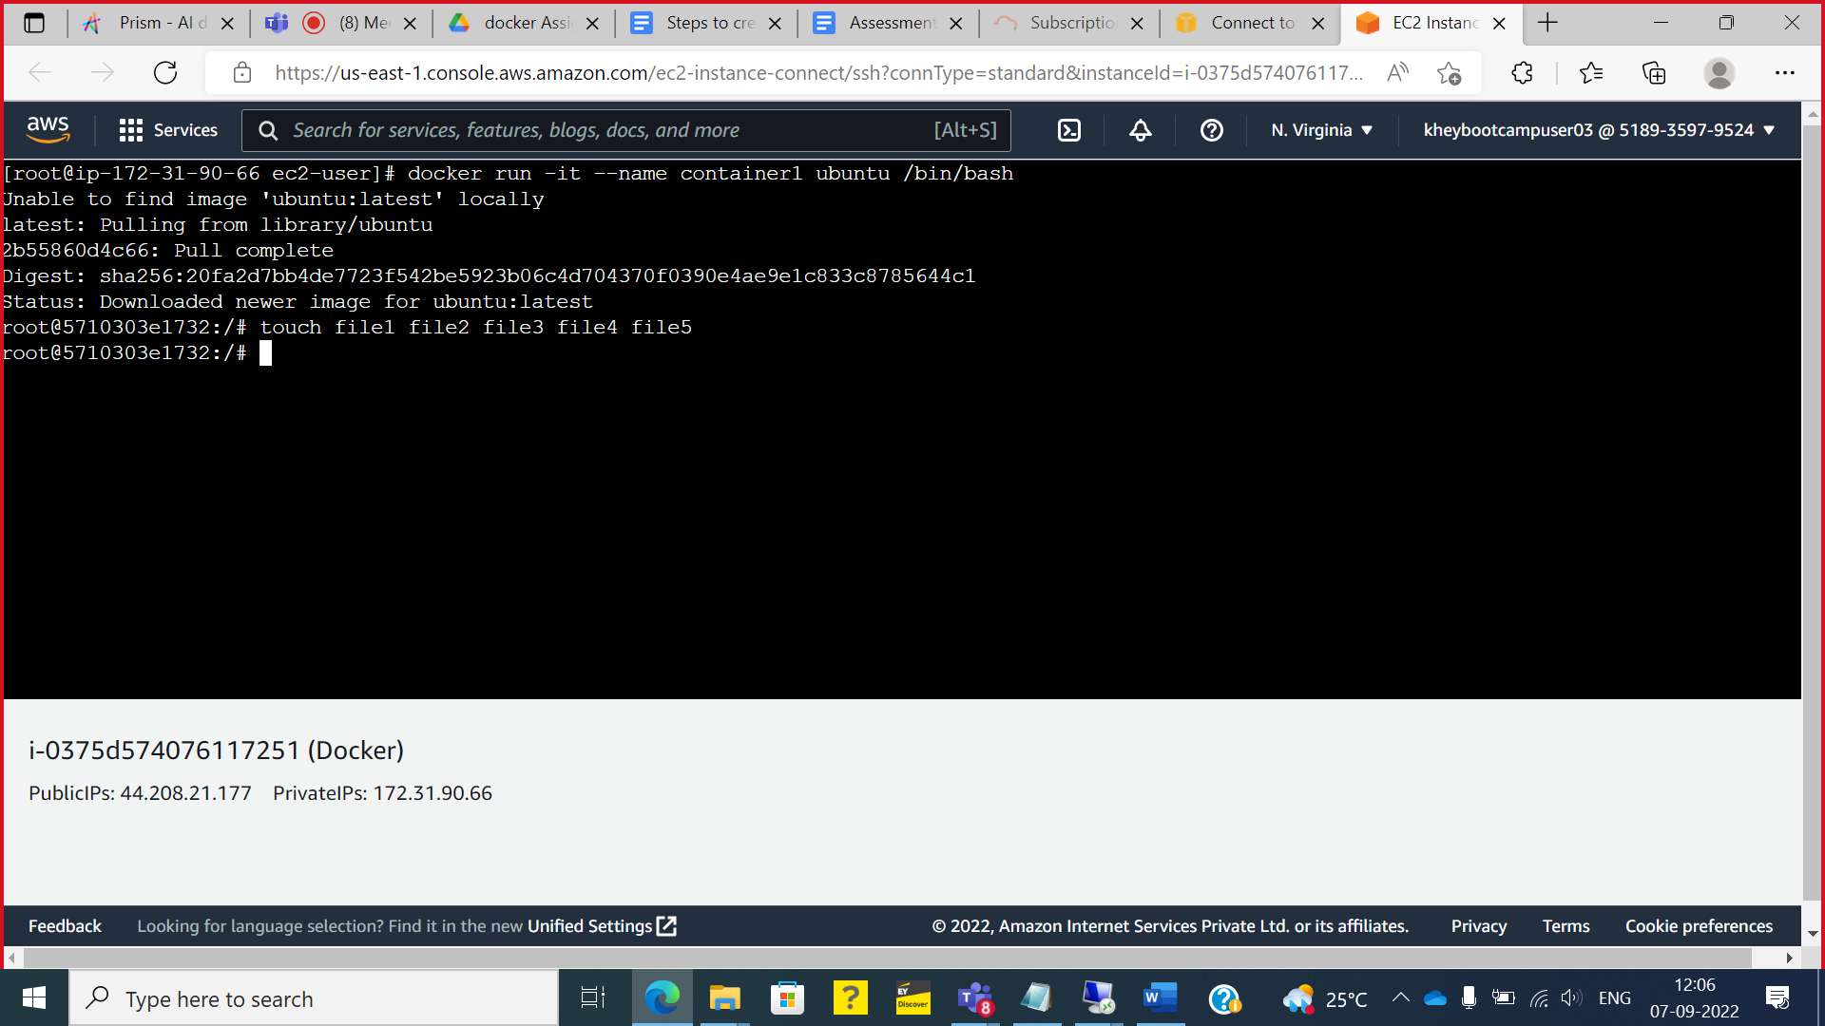

Now we have to create image of this container

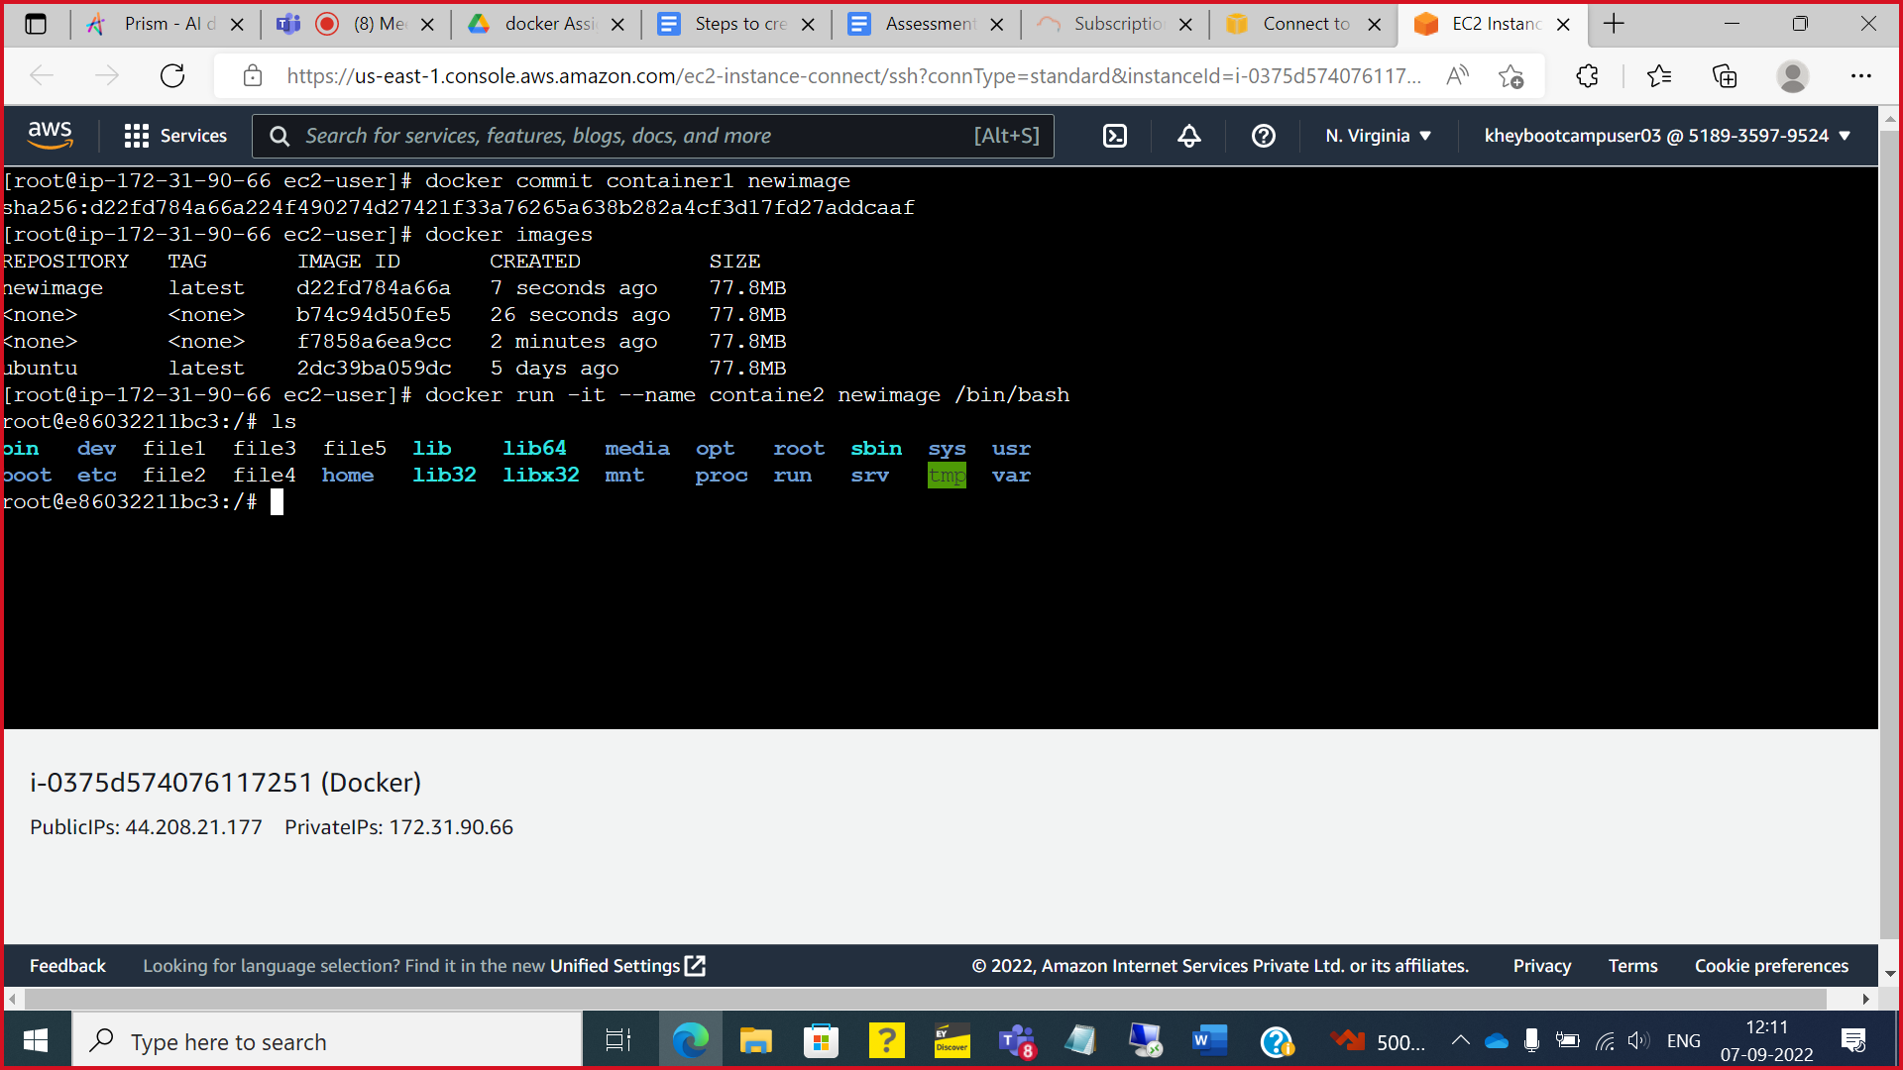

you will find the newimage also available in the set of existing images in docker engine



you will see the files which you have created in container 1

